Directional ETH FNG Regime Strategy

Purpose of this Report
To demonstrate complete understanding of the strategy's mechanics, to document every calculation in a form that can be independently reimplemented from this document alone, and to state the risk/return profile and the controls required before any capital is allocated.
The sections below give the full mathematical specification with worked numerical examples drawn from the actual dataset. These sections also cover evidence, risk, execution and recommendation.

Executive Summary
The strategy holds ETH long, short, or flat according to a daily rule built from four inputs — a 30-day price breakout, the 28-day change in a three-coin stablecoin supply basket, the perpetual funding rate, and the Fear & Greed index. No weights are fitted. The daily decision is expressed on hourly bars behind a trailing stop set at fifteen times ATR (14), with position size fixed so that the distance from entry to the initial stop costs exactly the risk intended.

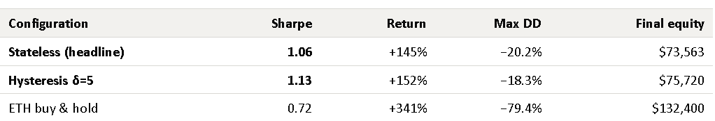

The case is risk reduction, not return. Buy and hold produced more than twice the profit over the same window; the strategy produced its result while never losing more than 13% from a peak, against 79% for buy and hold, and while holding a position only 47% of the time. Roughly half the profit came from short positions, so the result is not a disguised long-only bet on a rising asset.

Recommended for live execution on a small test account first.

1 – Strategy Overview

Asset Classes and Markets Traded
Crypto perpetual futures, USDT-margined, trading 24/7. The regime signal is computed from market-wide data (stablecoin supply, sentiment) plus per-asset price and funding.

Instruments Used
Instruments used include ETHUSDT perpetual and BTCUSDT perpetual.

Time Horizon
Multi-day position holding. The daily regime changes state roughly 220 times over 5.8 years; the median position is held several days. There is no intraday component and no forced flat — positions carry overnight and across weekends, so overnight gap risk and funding are both live exposures.

Trading Frequency
Low. 225 round trips over 2,120 trading days — approximately 39 per year, or one position change every nine days. The strategy is in the market 47% of the time and flat the remaining 53%. This low turnover is what makes the cost assumption survivable; a faster variant of the same signal does not survive costs.

Core Hypothesis and Market Inefficiencies
The hypothesis has two parts. First, that price trend alone is not a reliable directional signal in crypto. It produces too many false breakouts. Second, that the flow of stablecoin capital into and out of the system is a measurable proxy for whether there is real money available to sustain a move, and therefore acts as a confirmation filter on trend.
Expanding stablecoin supply means capital is entering the crypto system and has not yet been deployed into risk assets. That is fuel for a continuation upward. Contracting supply means capital is leaving, which removes the marginal buyer. The strategy therefore takes a breakout seriously only when the supply signal agrees with its direction, and stand aside when they disagree.
The two sentiment inputs play a smaller and purely defensive role. When both perpetual funding and the Fear and Greed Index sit at the bottom fifth of their trailing year range, the market is already maximally fearful, positioning is already short, and the asymmetry of adding a further short is poor. In that specific configuration, the strategy declines to short and stands flat instead. Sentiment can only remove a trade and it can never create one.

Why the Strategy Has an Edge
The claimed edge is a conditioning edge, not a prediction edge. It does not forecast returns. It filters a well-known and largely arbitraged signal (breakout trend) with a slower, less-traded signal (stablecoin flow) that is not priced into short-horizon order flow. The economic rationale is that stablecoin issuance and redemption reflect real fiat entering and leaving the system on a multi-week timescale, which is slower than most crypto participants trade.
The second component of the edge is structural rather than informational. There is a deliberately wide trailing stop on slow bars. The original research established that the same daily signal produces no usable result on daily close-to-close returns, and that the profit is created in the execution layer by allowing a position to run behind a stop wide enough not to be shaken out by ordinary volatility.

Discretionary, Systematic, or Hybrid?
Fully systematic. Every input, transform, decision, entry, exit, and size is deterministic given the data. There are no fitted weights and no optimizer anywhere in the specification. The parameters are chosen constants. Human intervention is limited to a kill switch that flattens and halts. There are no discretionary entries and no discretionary overrides of a stop.

2 – Strategy Mechanics (MS / EC/ PSL/ SL/ TP)
NOTE: CAUSALITY RULE: Every quantity in this section uses only information available strictly before the instant it is acted upon. A daily bar labelled D is complete only at 00:00 UTC on D + 1. A signal computed from D’s close is acted on the D + 2 open. Every hourly stop level uses the ATR computed through the prior bar. This is enforced mechanically in the code.

Market Structure (MS): The Four Signals
Four signals are computed daily. Three are transformed into a percentile of their own trailing year while the fourth is already discrete.

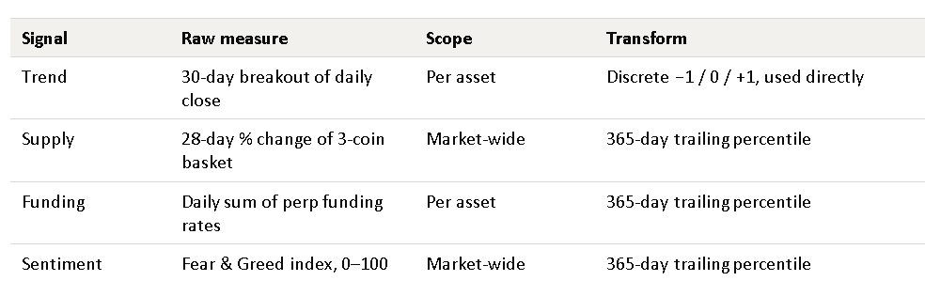

Trend: The 30-Day Breakout
The trend signal is a state machine, not an indicator. It flips to +1 the day the close exceeds the highest close of the preceding 30 days, flips to −1 the day it falls below the lowest, and otherwise holds whatever state it was in. It is therefore always long or short after the first breakout. It is never neutral and the neutrality in the final decision comes from the supply gate, not from trend.

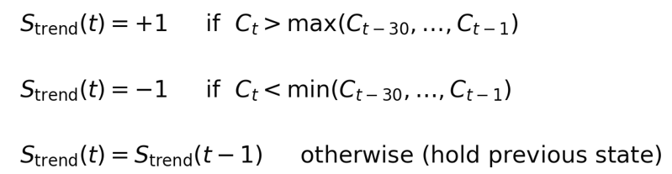

Reading It: C is the daily close. The comparison window ends at t – 1, so today’s own close cannot be part of the high or low it is being tested against. That shift is what keeps the signal causal. Because the state persists between breakout, a single breakout can keep the trend signal positive for months.

Worked Example: The trend flip on September 27. 2024
Prior 30-day window: 28 Aug 2024 to 26 Sep 2024
Highest close in that window: $2,652.00
Lowest close in that window: $2,223.70
Close on 27 Sep 2024: $2,693.53
Test: 2,693.53 > 2,652.00, so the upper breakout triggers
Trend state: −1 on 26 Sep and changes to +1 on 27 Sep

The Percentile Transform
Supply, funding, and sentiment are measured on incomparable scales. These scales include a percentage change, a rate in basis points, and an index from 0 to 100, respectively. Each is converted to its percentile within its own trailing 365 days, which make the decision thresholds meaningful across regimes and across time without rescaling.
Reading It: For the value observed on day t, count how many of the finite observations in the trailing 365-day window are less than or equal to it, and express that as a percentage. The window requires at least 335 valid observations, otherwise the transform returns NaN and the day is forced FLAT. A future value can never enter the window, so a percentile computed today can never be revised by tomorrow’s data.

Worked Example: Funding Percentile on September 27, 2024

Funding value that day (daily sum of settlements): 0.00023595 (2.36 bps)
Observations in trailing 365-day window: 365, of which 365 finite (≥ 335 required)
Count of window values ≤ 0.00023595: 133
Percentile = 100 × 133 / 365 = 36.44
Interpretation: funding that day sat in the lower third of its own trailing year — mildly cheap to be long.

Supply – The Three-Coin Basket
The supply signal is the 28-day percentage change of the summed circulating supply of three stablecoins: USDT on Ethereum, USDT on Tron, and USDC. The basket is summed only on days when all three members report, so a missing member produces no value rather than a distorted one.
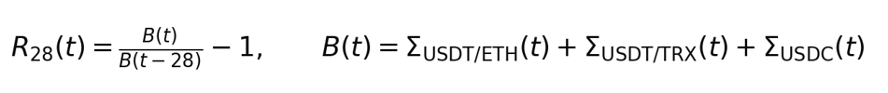
Reading It: B(t) is the basket total in dollars; the signal is its 28-day rate of change, which is then percentile-ranked. Including USDT on Tron is not optional.

Worked example — supply signal on September 27, 2024

Basket total on 27 Sep 2024: $152,265,992,198
Basket total 28 days earlier: $149,882,168,509
28-day rate of change = 152,265,992,198 / 149,882,168,509 − 1 = +1.5905%
Percentile of that value in its trailing 365 days: 45.48
Interpretation: supply was expanding in absolute terms, but more slowly than it had in most of the preceding year — so the percentile sits below the 50 split and the supply gate reads CONTRACTING. The gate is relative, not absolute.

Funding and Sentiment
Perpetual funding settles several times a day at timestamps that carry millisecond jitter and at an interval that is not constant through history. Both are handled explicitly: settlement timestamps are floored to the minute before any join, and the daily signal is the sum of all settlements stamped within the calendar day, so a change in settlement frequency does not change the meaning of the daily value.
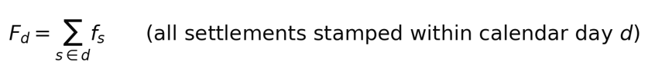
Reading it: The term f at settlement s is the per-interval funding rate. Summing within the day rather than averaging is deliberate. This makes the daily figure the actual cost of carrying a position for that day, which is invariant to whether the venue settles three times or twenty-four times. Fear & Greed is a single published integer per day and needs no aggregation, only the percentile transform.

Entry Conditions (EC): The Decision Rule
The four transformed signals enter a fixed decision rule. Trend proposes a direction; supply must agree with it; sentiment may veto a short. Nothing may create a position that trend and supply did not already agree on.

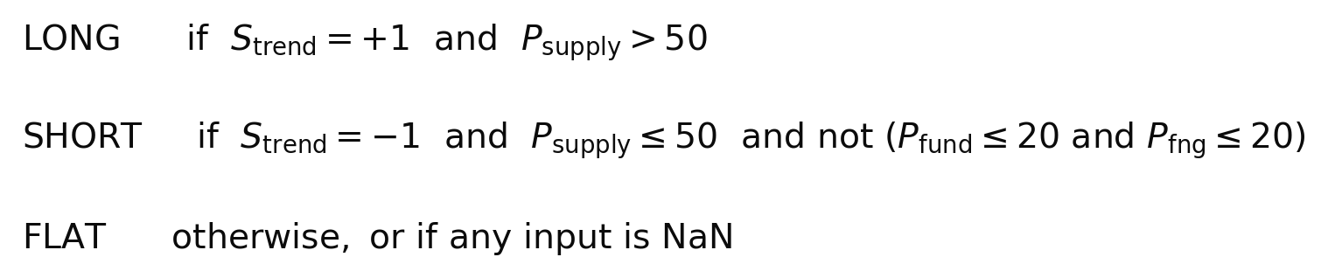

Reading it: P denotes a percentile. Note the asymmetry: the long branch has no sentiment condition at all, because in the Option A configuration the greed brake on longs is disabled. The short branch requires both sentiment measures to be at or below their 20th percentile simultaneously before it vetoes — requiring both, rather than either, is a deliberate choice that makes the veto rare.

Trend | Supply | Sentiment | Resulting state
Up | Expanding (>50) | not consulted | LONG
Up | Contracting (≤50) | not consulted | FLAT
Down | Contracting (≤50) | not both ≤20th pct | SHORT
Down | Contracting (≤50) | both ≤20th pct | FLAT (fear brake)
Down | Expanding (>50) | not consulted | FLAT
Any | any | any input NaN | FLAT

Worked Example: All Four Branches From Actual Dates
31 Mar 2024 trend +1, supply 95.3, funding 98.1, F&G 91.2 → LONG
supply is far above the split; the greed brake is off, so high funding and sentiment do not prevent the long.
30 Jun 2023 trend +1, supply 19.2, funding 72.9, F&G 82.5 → FLAT
trend is up but supply disagrees, so no position is taken. This is the gate doing its main job.
05 Jun 2023 trend −1, supply 32.9, funding 42.5, F&G 80.8 → SHORT
trend and supply agree downward; sentiment is nowhere near the fear extreme, so the short stands.
04 Aug 2024 trend −1, supply 20.0, funding 17.3, F&G 3.8 → FLAT (fear brake)
trend and supply both say short, but funding and F&G are BOTH at or below the 20th percentile, so the veto fires.

Over the full sample the fear brake fired on 188 of the 654 days on which trend and supply would otherwise have produced a short. That’s 28.7% of candidate short days. It is therefore a material component of the rule, not a rarely-triggered safety valve, and the requirement that both sentiment measures be extreme is what keeps it from being far more aggressive still.

The T + 2 Entry Lag
A state decided from day D's close is not traded until the open of day D+2. D+1 is a deliberate data-availability buffer: the stablecoin supply metric is published by its vendor after the UTC day closes, and treating it as available on the day it describes would be a look-ahead. The lag costs return and is the single most important reason the result can be trusted.

Worked Example — Lag Mapping for March 31, 2024 Signal
Signal day (state computed from this close): 31 Mar 2024
Buffer day (data becomes available): 01 Apr 2024
Action day (position opened at this open): 02 Apr 2024
Take note that in the hourly execution layer, every hourly bar on the action day and afterwards inherits that day's permission until the state changes.

Hysteresis Variant (Optional)
An optional refinement makes the supply gate sticky, to stop the strategy being whipsawed in and out when the supply percentile oscillates around 50.
Reading it: A position is only entered when the supply percentile is clearly on one side of the split (outside 50±5), but once held it is retained until the percentile crosses clearly to the other side. This creates a 45–55 deadband in which the previous state simply persists. It changes the state on 91 of 2,484 days, that’s under 4% of the sample.

Worked Example — A Day Where the Two Variants Disagree
12 Jun 2023 trend −1, supply percentile 54.79
Stateless: supply 54.79 > 50, so supply reads EXPANDING, which contradicts a down trend → FLAT
Hysteresis: the strategy was already SHORT, and 54.79 is still inside the 55 upper band → SHORT held
The refinement keeps the position through a marginal supply reading rather than closing and paying two turns of cost to re-enter.

Profit Side Logic (PSL)
Entry is immediate and unconditional once permission exists: when the strategy is flat and the lagged regime is non-zero, a market order is sent and filled at the next hourly bar's open. There is no entry timing model, no pullback wait, and no confirmation layer. The profit logic is entirely on the exit side — the position is held until either the trailing stop is hit or the regime changes, and the intended profit source is the long right tail of trends that survive both tests.

Stop Loss Logic (SL)
There is one stop: a trailing stop at fifteen times the 14-period average true range of the hourly bars. It never widens, only ratchets in the direction of the trade. There is no fixed disaster stop below it.

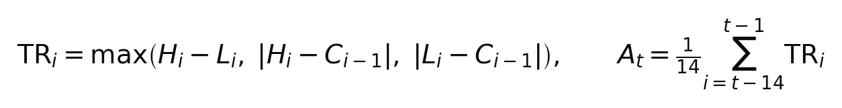
Reading It: True range is the greater of the bar's own range and the two gap-inclusive measures against the prior close, so an overnight gap is counted as real movement rather than ignored. The average runs over the 14 bars ending at t−1, so the ATR used to set the stop on bar t contains no information from bar t itself.

Reading It: For a long, the stop sits fifteen ATRs below the highest high seen since entry, and the outer max ensures it can only ever move up. The short case is the mirror image. Fifteen ATRs is deliberately very wide — roughly 20% of price on typical hourly ETH volatility — because the strategy is trying to stay in a multi-week move, not to manage an intraday drawdown.

Fill discipline on the stop is conservative: if a bar's open is already through the stop level, the fill is taken at the open rather than at the stop, which books the worse price. Only when the bar opens on the good side and trades through the level intrabar does the fill occur at the stop itself.
The second exit is the regime-flip exit, which is always on: if the lagged daily permission no longer matches the open position, the position is closed at the next bar's open regardless of where the stop sits. After a stop is hit, re-entry is locked out until the next calendar day, which prevents the strategy from immediately re-entering the same position it was just stopped out of.

Take Profit Logic (TP)
There is no take profit, and this is a deliberate design decision rather than an omission. The return distribution is strongly right-skewed. The strategy's result depends on a small number of large, long-held moves. A take-profit level truncates exactly that tail while leaving the losing tail untouched, which reduces both the mean and the Sharpe. Winners are held until the trailing stop or the regime removes them.

Position Sizing
Size is set from risk, not from capital. The notional is chosen so that if the position moves from entry to its initial stop, the loss is exactly a set amount, let’s say $2,000, subject to a leverage ceiling.

Reading It: Q is the position notional in dollars. Because the initial stop is 15 ATR away, dividing the fixed risk budget by that distance and multiplying by price gives the notional whose entry-to-stop loss equals the budget. Risk is a fixed dollar amount rather than a fraction of equity, so the strategy does not compound: a winning run does not increase the size of the next position. The leverage cap binds only when ATR is extremely small relative to price.

Worked Example: Sizing the 3 April 2024 long (At 2000$ Risk Per Trade)
Entry price (bar open): $3,280.67
ATR(14) through the prior bar: $45.09
Stop distance = 15 × 45.09 = $676.35
Initial stop = 3,280.67 − 676.35 = $2,604.32

Reading It: The notional works out at $9,701.10, which is 2.9570 ETH, and 0.32× leverage on the $30,000 base — far below the 25× cap, which did not bind. The final identity is the check that the sizing is correct: 2.9570 ETH moving $676.35 against the position is exactly the $2,000 risk budget.

Cost, Funding, and Accounting
Costs are charged on every turn and funding is applied at every settlement the position is open across.
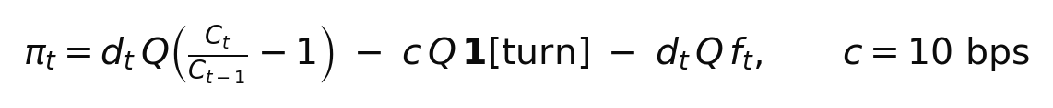
Reading It: d is the position direction (+1, −1 or 0), Q the notional, c the round-trip cost of 10 basis points (5 bps taker fee plus 5 bps slippage), and f the funding rate at that bar. The funding term carries the sign of the position, so a long pays positive funding and a short receives it. Equity is the running sum of these bar results added to the $30,000 base, for example.

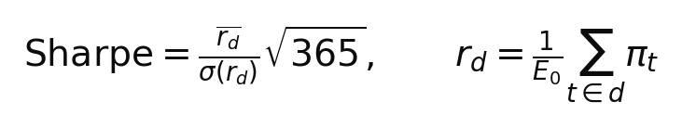
Reading It: Bar results are summed into calendar days, divided by the starting capital to give a daily return, and annualised by the square root of 365 because the market trades every day. Maximum drawdown is the largest peak-to-trough fall in the equity curve.
Important Note on the Accounting: The per-bar profit above multiplies a constant notional by each bar's simple return, which implicitly assumes the position is rebalanced back to constant dollar size every hour. A real position holds constant units instead. Measured across the full sample the difference is $747 on $43,037 of profit — 1.7%, and in the conservative direction, because the reported figure is the lower of the two. It is recorded here because it is a genuine modelling simplification, not because it is material.

Filters Used to Avoid Poor Trades
(1) Supply Gate: The primary filter. A breakout is not traded unless the stablecoin supply percentile agrees with its direction. This is what makes the strategy flat 53% of the time.
(2) Fear Brake: Shorts are vetoed when funding and sentiment are both at or below their 20th percentile. Fires on 28.7% of candidate short day.
(3) NaN Guard: Any missing or “not-yet-valid” input forces FLAT. This is a safety property.
(4) Post-Stop Lockout: After a stop, no re-entry until the next calendar day.
(5) Warm-Up: No trading until the percentile windows have at least 335 valid observations, which requires roughly 13 months of history before the first trade.

Data Inputs Required
Input | Source | Frequency | Used for
ETH perp OHLCV | Binance USD-M archive | 1-minute → 1d, 1h | Trend signal; execution bars; ATR
ETH perp funding | Binance USD-M archive | 8-hourly | Funding signal; carry cost
Stablecoin supply | Coin Metrics (SplyCur) | Daily, T−1 | Supply gate
Fear & Greed | alternative.me | Daily | Fear brake

Assumptions
(1) Five (5) basis points of slippage per side. This is an assumption inherited from the original research and has never been measured against a live fill.
(2) Stablecoin supply and sentiment data continue to be published on the same definitions. Both are third-party series outside the trader’s control.

3 - Backtesting and Results

Item | Detail
Backtest period | Regime from 27 Nov 2019; execution from 25 Nov 2020 to 14 Sep 2026
Data source | Binance USD-M official archive (1-minute klines + funding), integrity-audited against the exchange archive
Sample size | 2,484 regime days; 2,120 execution days; 225 round trips
Transaction cost | 5 bps taker per side
Slippage | 5 bps per side base; stressed at 10, 20 and 30 bps
Methodology | Fixed frozen specification; no parameter fitted on the evaluation sample; rolling walk-forward for out-of-sample confirmation

Verification Gates
The rebuild was gated on reproducing the validated reference states before any performance figure was accepted.

Gate | Result | Pass mark
Regime agreement vs reference manifest, ETH | 95.5% | ≥ 95%
Regime agreement vs reference manifest, BTC | 95.5% | ≥ 95%
Execution engine self-tests | 7 of 7 | 7 of 7
Independent second engine | Reconciles | Reconciles
1-minute data coverage | 100%, no gaps | —

The second engine is an independent implementation that reads only the pre-recorded daily states and in-memory bars, with no access to the signal calculation. Two implementations reaching the same result from different directions is the strongest available evidence that the number is not an artefact of one codebase.

Headline Results
Net of 10 basis points per turn and funding, on the Binance ETHUSDT perpetual, $30,000 nominal capital.

 | Sharpe | Return | Max DD | Trades | In mkt
Stateless | 1.06 | +145% | −20.2% | 225 | 47%
Hysteresis δ=5 | 1.13 | +152% | −18.3% | 203 | 47%
Coinbase spot cross-check | 1.04 | +145% | −23.2% | 226 | 47%
ETH buy & hold | 0.72 | +341% | −79.4% | 1 | 100%

Drawdown Convention: The -20.2% figure is a percentage of starting capital. The worst peak-to-trough fall was $6,096 against a $30,000 base. On the more usual measure, which is percentage of peak equity, the same fall is -12.8%, because the peak equity was $76,862. On the other hand, the buy-and-hold -79.4% is a percentage of peak. The two conventions are not interchangeable and the difference is stated here so that the comparison is not read as more favorable than it is.
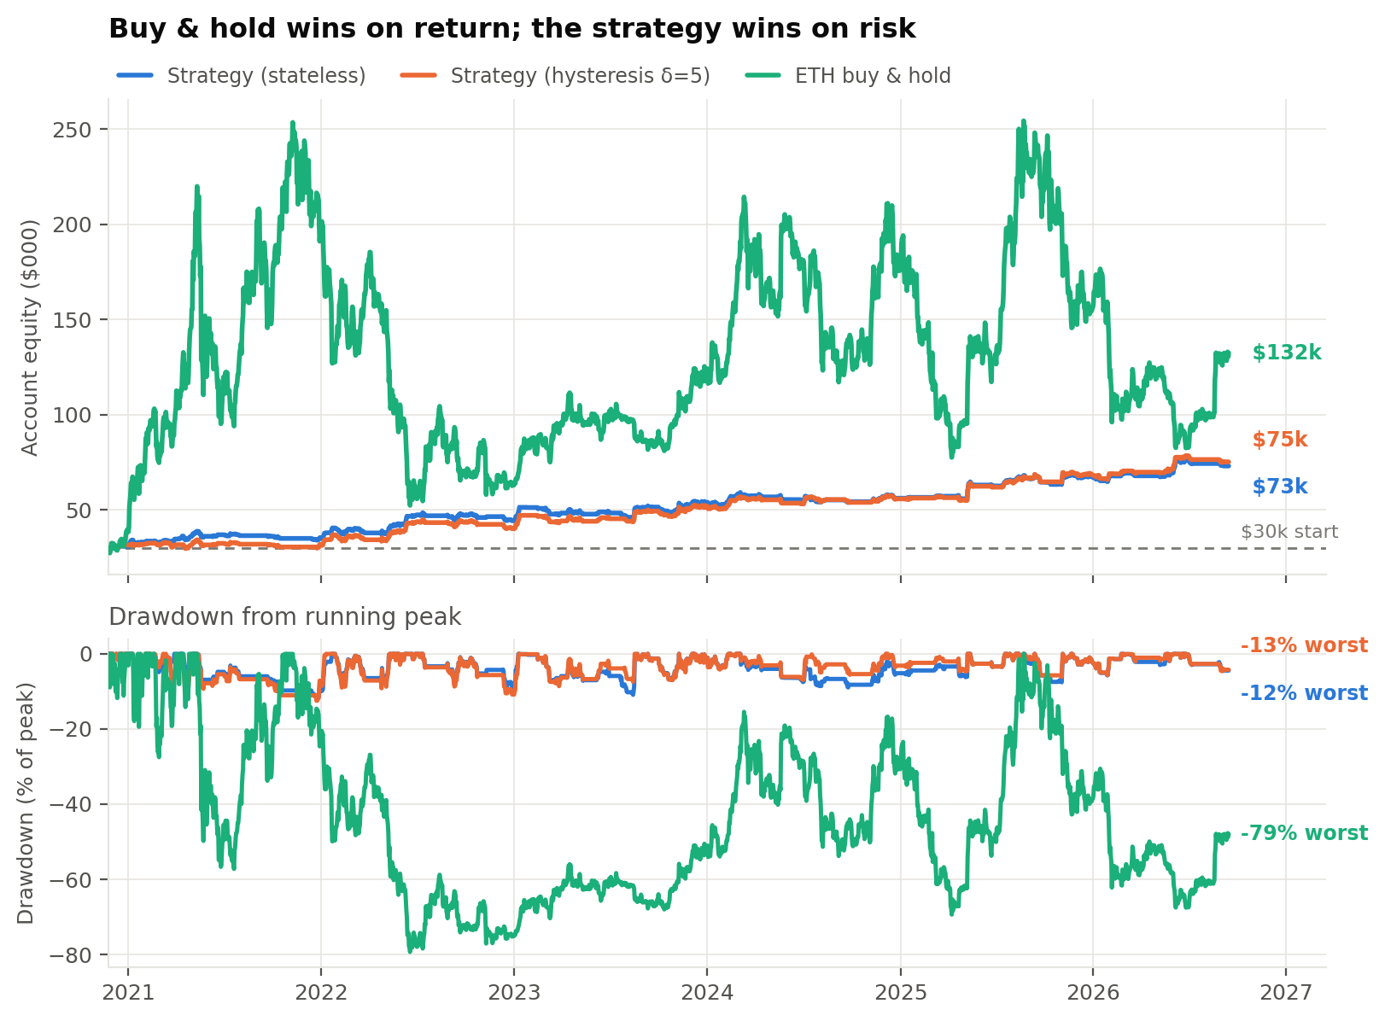

Profit and Loss Decomposition
The reported result is the net of three separable components. Decomposing them shows where the money is made and lost, and confirms that costs are a first-order term rather than a rounding adjustment.

Component | Amount | % of gross
Gross mark-to-market on positions | $52,074 | 100.0%
Transaction costs (225 round trips) | −$6,334 | −12.2%
Funding paid, net | −$2,703 | −5.2%
Net profit | $43,037 | 82.6%

Costs and funding together consume 17.4% of the gross result. That is a manageable fraction at this turnover, but it is also the reason the slippage assumption matters so much: doubling the slippage component roughly doubles the 12.2% cost drag, which is why the Sharpe falls below 1.0 at 10 basis points.
Split by direction, the long leg contributed $21,447 and the short leg $22,881. The short side is therefore not decoration as it is slightly the larger contributor, over a period in which the underlying asset appreciated 341%. A strategy earning everything from its long leg during such a period would be difficult to distinguish from a disguised long-only position.

Out-of-Sample Walk-Forward
The history was split into 24 consecutive 91-day windows. Each window begins with no open position and runs the same fixed configuration; the per-window results are then stitched into a single series. Because no parameter is refitted between windows, this tests whether the edge is distributed across the history or concentrated in one favorable period.

 | OOS Sharpe | Return | Max DD
Stateless | 1.04 | +146% | −20.6%
Hysteresis δ=5 | 1.08 | +150% | −18.2%

The stitched out-of-sample figure of 1.04 is effectively identical to the full-sample 1.06, which is the result this test is designed to check. The same test is much less kind to the hysteresis refinement as across the 24 windows it wins in 8, loses in 6, and is indistinguishable in 10. On that evidence its apparent full-sample improvement is inside the noise band, and it should be adopted for its consistently lower drawdown rather than described as additional return.

Transaction Cost Sensitivity
This is the most significant open question in the analysis. The 5-basis point slippage figure is an assumption, not a measurement.
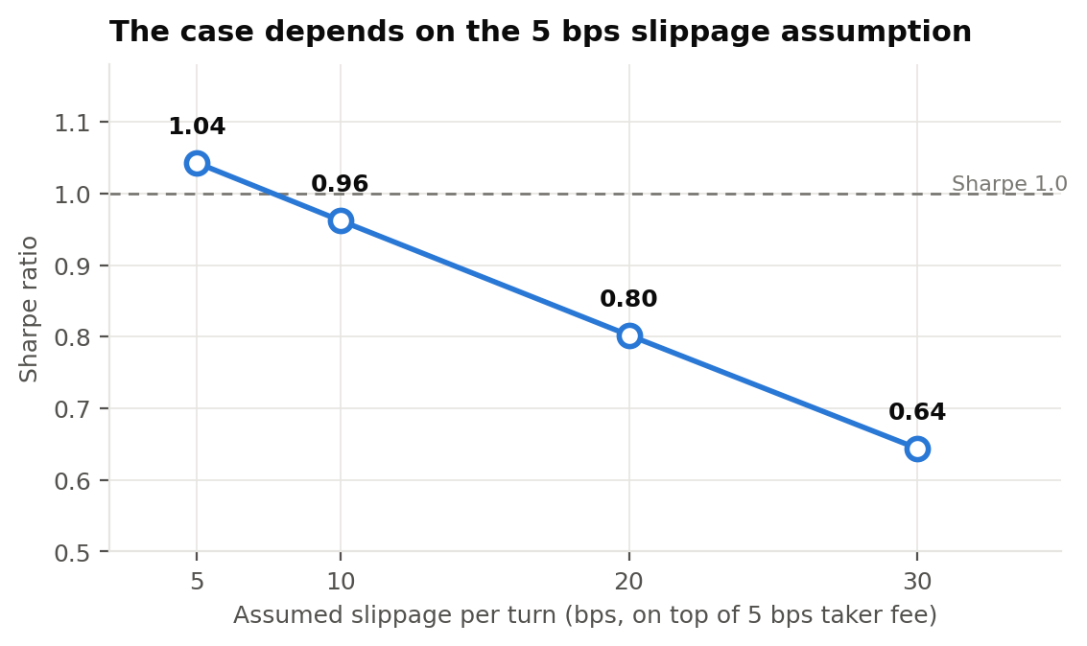

Slippage per turn | 5 bps | 10 bps | 20 bps | 30 bps
Sharpe | 1.04 | 0.96 | 0.80 | 0.64
Return | +145% | +134% | +112% | +91%
Max drawdown | −23.2% | −24.2% | −26.2% | −28.2%

At 10 basis points the Sharpe falls below 1.0; at 20 it falls to 0.80. The low turnover — 39 round trips a year — is what keeps this survivable, and a faster variant of the same signal would not be. Measuring realized slippage against this assumption should be the first purpose of any live allocation.

Venue Sensitivity
Running the identical strategy on Coinbase ETHUSD spot rather than the Binance perpetual gives 1.04 against 1.06, with a somewhat worse drawdown. That the result barely moves across two venues with different liquidity, different fee structures and different participants is reassuring. It also resolves a weakness in the original research, which validated on spot data while intending to trade a perpetual contract.

4 – Expected Return and Risk Profile

Maximum Capital Requested
A limited forward-test allocation, sized so that the loss of the entire allocation is immaterial. The purpose of the first quarter of live trading is to measure realized fills against the assumptions above. The $30,000 nominal figure used throughout this report is the research base and is not a capital request.

Risk Limits
- Per Trade: The risk per trade on the backtest and forward tests is $2000 to the initial stop by construction. On a $30,000 base that is 6.7% of capital per trade, which is well above a conventional per-trade limit and requires an explicit decision rather than inheritance from research configuration.
- Realized Worst Day: -$2,110, consistent with the per-trade design.
- Drawdown: Realized maximum at -$6,069 (-20.2% of base, -12.8% of peak). Proposed governors include a -5% of base for review and a -10% for a halt pending investigation.
- Leverage: Capped at 25x, but non-binding in practice. The worked example sized at 0.32x. Effective leverage under fixed-sizing risk is typically well under 1x.
- Account Survival: The minimum equity reached over the whole sample was $29,401 against the $30,000 base. The account never approached failure but this is not a guarantee in future returns.

Liquidity Constraints
Negligible at research size. Average position notional is under $10,000 on the most liquid crypto perpetual in existence, entered with market orders at hourly opens. Liquidity would only become a consideration at a scale several orders of magnitude above the proposed forward test.

Correlation Risk
The strategy is directional and long-biased in aggregate exposure, holding a position 47% of the time. It is not market-neutral and should not be presented as a diversifier against directional crypto exposure. It is correlated to ETH by construction when long. Its diversification value comes from being flat 53% of the time and from a short leg that is active in exactly the conditions a long-only book suffers.

Tail Risk
The dominant rail risk is an overnight or weekend gap through the trailing stop. Within the research environment, the stop is checked on hourly bars, so a move that gaps past it between bars fills at the open. The engine models this conservatively by taking the worse of the two prices, but a genuine exchange-level dislocation could exceed even that. Because positions are held across weekends and there is no hard disaster stop beneath the trailing stop, the loss on such an event is not bounded by the risk budget per trade.

What Could Cause the Strategy to Fail
(1) Costs above assumption. Realized slippage near 10 bps takes the Sharpe below 1.0, near 20bps it becomes marginal. This is the most likely failure mode and the cheapest to test.
(2) The supply signal decoupling. The economic premise is that stablecoin issuance tracks real capital entering crypto. If issuance becomes dominated by mechanics unrelated to risk appetite (e.g. collateral rotation, regulatory migration between chains, a new dominant stablecoin outside the three-coin basket), the signal degrades without any visible break.
(3) Third-party data. Supply and sentiment are external free series with no service guarantee. Loss of either forces the strategy flat, silently.
(4) Sample fragility. Roughly 1.5 market cycles on a single historical path underlie everything here. The out-of-sample windows overlap that same history and no statistical treatment created independent evidence that does not exist.

5 - Execution Plan

Venue and Instruments
ETHUSDT perpetual futures asset on chosen venue such as Kucoin, Coinbase, and Binance.

Order Types and Timing
- Entries and Exits: Market orders, filled at the next hourly bar open.
- Stop: Evaluated on hourly bar highs and lows, executed as a market order on breach. It is not resting the exchange. This is a synthetic stop help by the strategy process, which means process downtime is a real risk requiring monitoring.
- Regime-Flip Exit: Evaluated once per hourly bar against the lagged daily state.
- Re-Entries Rejected: No re-entry on the same calendar day as the stop.

Monitoring
- Realized slippage per fill against the 5bps assumption, reported daily. This is the primary purpose of the forward test.
- Data staleness on all four inputs. A missing input forces FLAT without raising an error, so the absence of a signal must itself be alarmed.
- Position and equity reconciliation against the exchange, daily.

Manual Override
Kill switch only to halt and flatten the positions. No discretionary entries, no discretionary stop adjustments, no parameter changes while live. Any specification change requires a fresh frozen backtest and a new sign-off.

6 — Portfolio Fit

Correlation to Existing Strategies
Structurally different from an intraday or market-making book. It holds multi-day directional positions and is exposed overnight. It should be assumed to correlate with any existing directional crypto exposure while long, and to hedge it while short. Realized correlation to the live portfolio must be measured during the forward test rather than assumed from the strategy description.

Capital Efficiency
High. Fixed-risk sizing produces effective leverage typically well under 1×, so the margin required is small relative to the notional traded, and the strategy is flat 53% of the time, freeing capital. The non-compounding design means capital efficiency does not improve as the account grows. This is an intentional conservatism that also caps the strategy's ability to scale returns without an explicit sizing decision.

Expected Contribution
Not material during the forward test, by design. The contribution in this phase is informational: whether realized fills, realized slippage and realized correlation match the assumptions.

Conflicts and Overlaps
Shares venue and margin capacity with any existing perpetual activity. If another book trades ETH perpetuals, aggregate exposure and aggregate liquidation risk must be managed at the account level, not per strategy. The sizing logic here is unaware of any other position.

7 – Recommendation
Approve a staged deployment, not a full one. The strategy is correctly specified, faithfully replicated, and verified against an independent implementation. The edge is real and modest.
The case to put is risk reduction and a two-sided edge, not return. Buy and hold produced more than twice the profit over the same window and will do so again in any sustained bull market. What this strategy offers is roughly comparable risk-adjusted performance achieved with a sixth of the drawdown, half the time in market, and a short leg that earns in precisely the conditions a long-only book suffers.

